Kindergarten  - 2 Boxes of 24-count Crayola crayons  - 3 Packages of Ticonderoga pencils (regular, 12 count)  - 6-8 Glue sticks  - 2 Bottles of school glue  - 1 Pair of Friskers scissors  - 1 Plastic pencil box  - 2 Five Star 2-Pocket Stay-Put Plastic Folders  - Change of clothes (labeled in a gallon Ziploc bag)  - 2 Boxes of tissue  - 1 Container of disinfectant wipes  - NKJV Bible for kids  1st Grade  - 1 Box of Crayons  - 1 Package of 2 pink erasers  - 1 Package of glue sticks  - 1 Pair of scissors  - 2 Pencil Boxes  - 1 Package of #2 pencils (12 count)  - 1 Box of colored pencils (12 count)  - 2 Pocket folders  - 1 Package of washable markers  - 1 Package of dry erase makers  - 2 Composition notebooks (wide-ruled)  - 1 Box of tissue  - 1 Box of Ziplock bags  - 1 Personal dry erase board  - 1 Container of disinfectant wipes  - 1 Small bottle of hand sanitizer  - 1 Water bottle labeled with child’s name  - NKJV Bible for kids  2nd Grade  - 1 Box of crayons  - 1 Box of washable markers (12 count)  - 1 Box of colored pencils (12 count) | - 1 Pair of scissors  - 1 Package of Glue sticks  - 2 Bottles of white glue  - 1 Personal dry erase board  - 1 Package of black expo markers  - 1 Container of disinfectant wipes  - 1 Box of tissue  - 1 Plastic pencil box  - 1- 1” 3 ring binder  - 1- 3 Prong folder, with pockets  - 1 Package of construction paper  - 1 Bottle of hand sanitizer  - 1 Box of gallon Ziploc bags  - 1 Ruler  - 2 Packages of #2 pencils (12 count)  - 1 NKJV Bible  3rd/4th Grade  - Standard size storage crate  - 2 Boxes of Ticonderoga pencils (12 count)  - Colored pencils (12 count)  - 2 Boxes of crayons (24 count)  - Glue sticks/ white glue  - 2 Packages of wide-ruled paper 100 count  - Standard size Post-it notes  - 1 Package of pink erasers  - 2 Pencil boxes  - 2 Pocket folders with brads  - 1 Single subject spiral notebook  - 1 Pair of scissors  - 1 Box of tissue  - 1 Container of disinfectant wipes  - NKJV Bible | 5th/6th Grade  - 2 Boxes of Ticonderoga pencils (12 count)  - Pencil box  - 1 Package of colored pencils (12 count)  - 1 Package of markers (12 count)  - 1 Package of lined paper  - 1 Package of white printer paper  - 1 Container of disinfectant wipes  - 1 Protractor  - 1 Ruler  - 1 Package of graph paper  - 1 Box of tissue  - 1 Bottle of hand sanitizer  - 1 3-Ring binder  - 4 Composition notebooks  - 1 Package of 2 pink erasers  - 2 Packages of glue sticks  - 1 Pair of scissors  - NKJV Bible  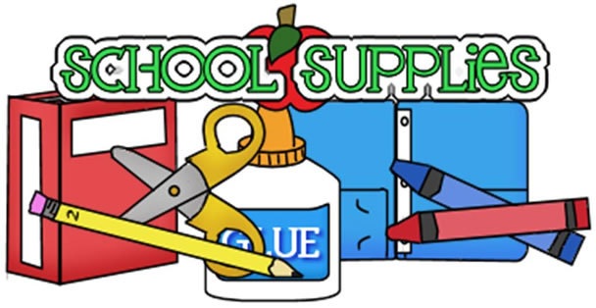  6/21

